Southern Tier Chapter of
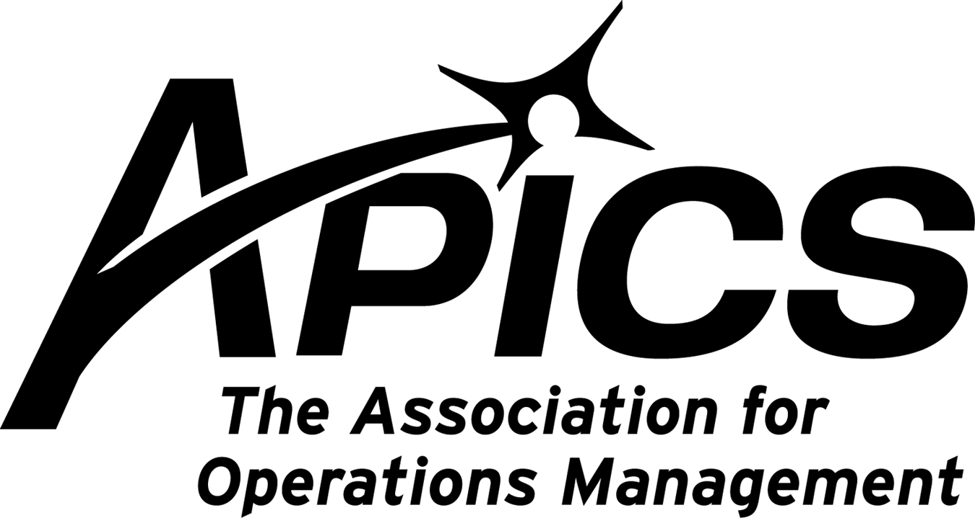
www.stapics.org

“Advancing productivity and innovation and competitive success.”

APICS MEMBER APPRECIATION NIGHT

Thursday, June 23rd, 2011

Location: Jonathan’s
Hooper Road, Endwell

5:30PM Sign-in and Networking
6:00PM Dinner
6:45PM APICS BOK (Body of Knowledge)
Presented by: Don Sheldon

Dinner: Pizza, wings, sandwiches, soft drinks & beer

Cost: Members FREE. Non-members $20.

If you are a member, or have attended an APICS sponsored class, seminar, or meeting this past year you are invited.

Send RSVP via email to Michael.losapio@synergyresources.net or call 607-786-3487

APICS BOK (Body of Knowledge) Update
The APICS BOK Committee is the content committee governance for the services and products APICS sells. This includes the annual APICS conference, the Asian APICS conference, the Best of the Best S&OP conference as well as the courseware available for the various offerings. Donald H Sheldon has been the Chair of the APICS BOK (body of Knowledge) since Jan 2010. The role of the committee is to prioritize the activities and goals as guidance to the APICS BOD (Board of Directors). Mr. Sheldon will be addressing the PDM this month on the activities and direction of the BOK. Topics he will cover:

- Product life cycle updates.
- Directional activities of APICS
- Courseware updates
- Q&A

About the Speaker


Mr. Sheldon is the president and principal of DHSheldon & Associates LLC where he travels world wide helping companies achieve manufacturing excellence. Mr. Sheldon has been a speaker at numerous APICS International Conventions and has authored numerous articles and six books. He is currently the Chair of APICS BOK and sits on the APICS VOC (Voice of the Customer) Committee and the SDC (Strategic Direction Committee). He can be reached at dsheldon@sheldoninc.com.

DHSheldon & Associates LLC, www.sheldoninc.com

President’s Memo
Dave Gardner, CPIM

I am proud to announce that our very own Education Director has been nominated to continue his work on the APICS body of Knowledge for 2 more years.

Donald H. Sheldon, CFPIM, CIRM, CSCP, was nominated by the committee to serve as the Body of Knowledge
Committee Chair for the 2012 - 2014 term.

Congratulations, Don! It is a pleasure having you in our chapter and part of our Board.

Come join the Board of Directors
Unlike some other organizations, the Board of Directors of your chapter is not self-perpetuating. We are always looking for new blood to reenergize us. We encourage you to join us in planning the trajectory of your local APICS chapter. If you’re interested, contact any member of the board. Why should we have all the fun?

We’re on !!!
Come and visit, poke around, or comment on us! Our name there is “Southern Tier Apics”. It’s just another way
for us to keep in touch with our membership.

For the latest in chapter happenings check out WWW.STAPICS.ORG



Your 2011-2012 Board of Directors

President / VP Education Dave Gardner dgardner@akraturn.com
VP Membership / Website Lee Schechter lschechter@stny.rr.com
Executive VP / Director of Finance Steve Whited steve.whited@mwv.com
Director of Education Don Sheldon dsheldon@stny.rr.com
Publicity / Marketing / Programming Michael LoSapio Michael.losapio@synergyresources.net
Marketing Director Kelly Norieka Kelly.norieka@lmco.com
Secretary Deb Unkel deb.unkel@raymondcorp.com
Director at Large Steve Stanchak steve.stanchak@infoprint.com
Director at Large Brian Arnold barnold@amphenol-aao.com

Southern Tier APICS
PO Box 1107
Binghamton NY 13902-1107

